Down the Rabbit Hole - an aaBridge Key Feature
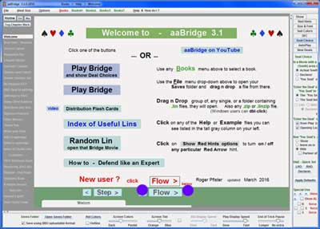
The Welcome screen of aaBridge leads to an introductory guide for all new users. (Click Flow to follow this – purple dots)
In the left hand column is an entry named Down Rabbit Hole. Click on it to make it show, or you can keep clicking Flow to get to it that way. As you move forward through the Down Rabbit Hole "lin" file (aka, Bridge Movie) you will get to a deal.
4

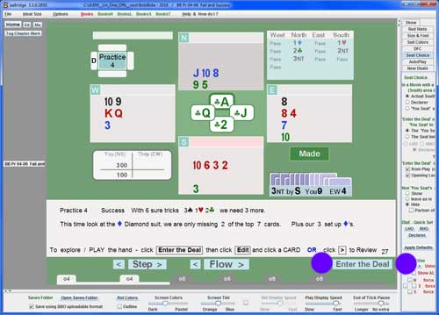
Hands on - You can use that example deal OR perhaps you have been sent a lin file by a friend or a bridge teacher in which case you can use that file. Start aaBridge then drag and drop that new lin file onto the open aaBridge window. That lin file will open.
Here a tutorial lin file is showing about a third of the way through. You can see this is so by the length of the cream area of the Navbar (the clickable line with bumps on it just below the Step and Flow buttons).
Note - the Enter the Deal button (purple dots) will take you "Down the Rabbit Hole".
As you play a tutorial lin file (like the one shown), aaBridge controls what you see. You click the Flow button and the tutorial moves forward to the next thing you are intended to see. You have very little control -- just moving (or jumping) forwards or backwards.
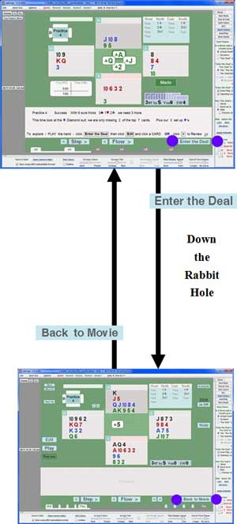
When you click Enter the Deal (purple dots) everything changes -- you go "Down the Rabbit Hole".
Once you have dropped down the Rabbit Hole you are the boss, you are in control.
You control what you see. You can change the opponents play or via the Edit button change the opponents cards, your cards or the bidding.
The two single '<' '>' buttons to the right of the Flow > button let you view any play card by card. Once one has been clicked the mouse wheel will provide 'more of the same'.
It is always best to use your mouse wheel if you have one.
At any time, you can save the resulting hand with its bidding, and play it as a .lin file.
When you are finished exploring this particular deal, click Back to Movie (purple dots) and return to the tutorial, or upper layer Bridge Movie. Now, you can resume playing the tutorial from exactly where you were before you went "down the rabbit hole".
FYI - Single deal lin files are automatically opened starting, "Down the Rabbit Hole" the is because that is what you normally want to see.
aaBridge can do many things. Take your, time don't expect to master it overnight. The more you investigate it the more you will see what it can do for your Bridge comprehension.
Kib Seat
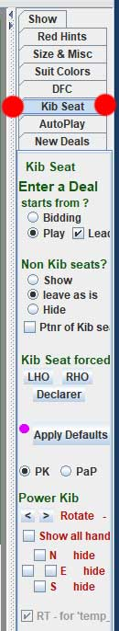
The seat choice controls, which can be found in the right-hand column of aaBridge, are the most important of all the additional settings.
The Kib Seat (red dots) controls will normally be showing whenever you are in a tutorial or a deal.
These controls allow you to change the way, and what you see when a deal is displayed while you are “down the rabbit hole” in the "inside a deal" mode.
Because they are powerful there is an undo and get back to normal button. This button is labelled Apply Defaults (it has a real pink dot to catch your eye).
This is your "put everything back to normal" button.
You cannot use it too much. :)

Edit Play Review
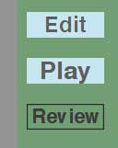
These buttons appear when you are inside a deal. They are like a set of "radio buttons". There will always be one of them selected, this shows the mode you are working in.
Review lets you look at any existing play in the deal.
Play will let you play against the aaBridge bots.
Edit will let you change anything you want, including setting played cards for the opponents.
Remember to explore.

